**Worship on the Ninth Sunday After Pentecost**

July 21, 2024, at 10:00 a.m.

Dr. Clifford Anderson, Guest Preacher

The Rev. Dr. Rosanna Anderson, Designated Term Pastor

Organist Diane Dawson Dexter

**Prelude**

**Welcome** Dr. Rosanna Anderson

**Call to Worship**  Psalm 43:3-4

O God, send out your light and your truth; let them lead me.

**Let them bring me to your holy hill and to your dwelling.**

Then I will give praise to the Lord, to God my exceeding joy.

**I will praise you in the congregation, O Lord my God.**

**Opening Prayer**

**Dear God, giver of life and health, your Son Jesus has called us to hunger for justice and thirst for righteousness to prevail. Refresh us with your grace, that we may not be weary in well-doing, for the sake of him who meets all our needs, Jesus Christ our Savior, who lives and reigns with you and the Holy Spirit, one God, now and forever. Amen.**

**Hymn 558** “We Are the Church”

**Prayer of Confession \***

**Holy God, your steadfast love endures forever. We confess that we long to rest in you, and to trust in your care for us, but we don’t know how to rest, and we have forgotten how to trust. We seek material goods that we don’t really need.**

**We befriend people not always out of love. We ask you questions that try only to prove our point, not to grow in understanding of your will for us. Slow us down. Help us to see that you are our resting place and our salvation. Amen.**

**Assurance of Forgiveness**

**Prayer for Illumination**

**Old Testament**  Psalm 89:20-37

**New Testament** Ephesians 2:11-22

**Sermon** “Breaking the Law” Dr. Clifford Anderson

**Musical Interlude** Annie Packard

**Offertory**

**Doxology** Praise God from whom all blessings flow.

Praise him, all creatures here below.

Praise him above, ye heavenly host.

Praise Father, Son, and Holy Ghost. Amen.

**Prayer of Dedication**

**O Lord, you are the source of all goodness. Thank you for patiently calling us to trust you with our whole heart. Refresh us by your Spirit so that we may lead others to you. We give these offerings in the name of Jesus Christ, who multiplied the loaves and fish so that everyone had more than their fill. Amen.**

**Sharing Praise and Prayer Concerns**

**Prayers of the Church and the Lord’s Prayer** (*trespasses*)

**Hymn 399** “Take My Life and Let It Be”

**Benediction** Dr. Anderson

**Postlude**

*adapted from a prayer by Rev. Catherine Rolling on re:worship

**Church Calendar**

Sunday, July 21

8:00 a.m. **Beach Church** at Dock Beach

9:00 – 9:45 a.m. **Big Questions** Class at Union Chapel

10:00 – 11:00 a.m. **Worship and Fellowship** here and online

Tuesday, July 23 **Media Lab for Good** 9:00 – 11:00 a.m.

Ms. Jess Hall will teach free lessons on how to make a podcast.

Wednesday, July 24 **Bible Study** 9:00 – 10:00 a.m.

Join us in the Parlor or online to learn more about this saying of Jesus: “I Am the Good Shepherd” with the theme “Knowing God’s Care” (pages 55 - 67). The Zoom link is on our website.

Thursday, July 25 **Moms and Tots** 10:00 – 11:00 a.m.

Drop by and share in refreshments, play time, and conversation.

Saturday, July 27 **Board Game Café** 5:00 – 6:30 p.m.

Join us for free pizza dinner and a wide variety of fun board games for the whole family! RSVP to Pastor Rosanna in the church office at 788-7898 by noon on Friday with the number of people and your favorite kind of pizza.

Sunday, July 28

8:00 a.m. **Beach Church** at Dock Beach

9:00 – 9:45 a.m. **Big Questions** Class at Union Chapel

10:00 – 11:00 a.m. **Worship and Fellowship** here and online

**Union Chapel (United Church of Christ)**

*Sign up for our weekly newsletter!*

[www.fiunionchapel.org](http://www.fiunionchapel.org)

**The Rev. Dr. Rosanna Anderson, Designated Term Pastor**

Becky Walters, Administrative Assistant

Laura Chapman, Sexton

Diane Dawson Dexter, Organist

*“Whoever you are and wherever you are on*

*your faith journey, you are welcome here.”*

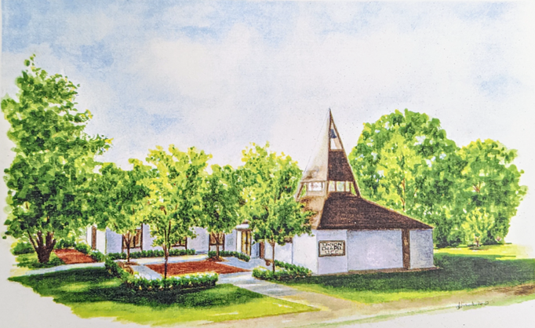

**Dr. Clifford Anderson**

July 21, 2024

**Union Chapel (United Church of Christ)**

P.O. Box 192

821 Crescent Avenue

Fishers Island, NY 06390

[www.fiunionchapel.org](http://www.fiunionchapel.org)

788-7898