**Worship on the Eleventh Sunday After Pentecost**

August 4, 2024, at 10:00 a.m.

The Rev. Dr. Rosanna Anderson, Designated Term Pastor

Organist Diane Dawson Dexter

**Prelude**

**Welcome** Dr. Rosanna Anderson

**Call to Worship**  Psalm 78:23-29

God commanded the skies above and opened the doors of heaven;

**God rained down manna to eat and gave the people the grain of heaven.**

Mortals ate of the bread of angels; God sent them food in abundance.

**God caused the east wind to blow in the heavens, and powerfully led out the south wind;**

he rained flesh upon the people like dust, winged birds like the sand of the seas;

**God let the quail fall within their camp, all around their dwellings. And they ate and were well filled, for God gave them what they craved.**

**Hymn 577** “God of Grace and God of Glory”

**Prayer of Confession**  fromPsalm 51

**Have mercy upon us, O God, according to your steadfast love; according to your abundant mercies, blot out our sin. Create in us a clean heart, O God, and put a new and right spirit within us. Restore to us the joy of your salvation and uphold us with a willing spirit. We pray through Jesus Christ our risen Lord. Amen.**

**Assurance of Forgiveness**

**Prayer for Illumination**

**Old Testament**  Exodus 16:2-15 (pew Bible p. 60-61)

**New Testament** Ephesians 4:1-16 (pew Bible NT p. 182)

**Sermon** “Measuring Up” Dr. Anderson

**Offertory**

**Doxology**

**Prayer of Dedication**

**Gracious God, thank you for making each of us a beloved child in your great family. You guide us by your Spirit to the way of life. Through your grace, we have enough to share with our neighbors who are in need. May our gifts bring your kindness through our church’s ministries. We pray through Christ, who loved us and gave himself as a fragrant offering and sacrifice for us all. Amen.**

**Invitation to the Lord’s Supper**

The Lord be with you. **And also with you.**

Lift up your hearts. **We lift them up to the Lord.**

Let us give thanks to the Lord our God.

**It is right to give God thanks and praise.**

(*Prayer continues*.) … Therefore, we praise you, joining our voices with the choirs of angels, with prophets, apostles, and martyrs, and with all the faithful of every time and place who forever sing to the glory of your name:

**Holy, holy, holy Lord, God of power and might,**

**heaven and earth are full of your glory.**

**Hosanna in the highest. Blessed is he who comes in the name of the Lord. Hosanna in the highest.**

(Prayer continues.) … Great is the mystery of faith:

**Christ has died. Christ is risen. Christ will come again.**

**Prayers of the Church and the Lord’s Prayer** (*trespasses*)

**Sharing of the Elements and Prayer After Communion**

**Hymn 384** “Love Divine, All Loves Excelling”

**Benediction** Dr. Anderson

**Postlude**

**Church Calendar**

Sunday, August 4 8:00 a.m. **Beach Church** at Dock Beach

10:00 – 11:00 a.m. **Worship and Fellowship** here and online

Tuesday, Aug. 6 **Free Lessons** in the Media Lab for Good

Ms. Jess Hall gives instructions in podcasting and video editing.

Wednesday, Aug. 7 **Bible Study** 9:00 – 10:00 a.m.

Join us in the Parlor or online to learn about this saying of Jesus: “I Am the Way, the Truth and the Life” (pages 87 – 102).

Thursday, Aug. 8 **Moms and Tots** 10:00 – 11:00 a.m.

Drop by and share in refreshments, play time, and conversation.

Saturday, Aug. 10 **Thrift Shop** 10:00 a.m. – noon

Help the environment by purchasing gently used items that have already been shipped here.

Saturday, Aug. 10 **Memorial Service** 11:15 a.m.–12:15 p.m.

Join us onsite or online as we give thanks for Mary Jean Pelham’s life and faith. The Zoom link is the same for all worship services.

**Union Chapel (United Church of Christ)**

*Sign up for our weekly newsletter!* [www.fiunionchapel.org](http://www.fiunionchapel.org)

**The Rev. Dr. Rosanna Anderson, Designated Term Pastor**

Becky Walters, Administrative Assistant

Laura Chapman, Sexton

Diane Dawson Dexter, Organist

*“Whoever you are and wherever you are on*

*your faith journey, you are welcome here.”*

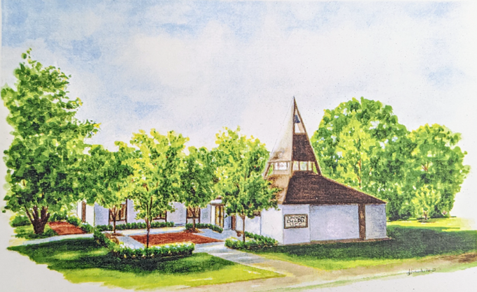

**The Rev. Dr. Rosanna Anderson**

August 4, 2024

**Union Chapel (United Church of Christ)**

P.O. Box 192

821 Crescent Avenue

Fishers Island, NY 06390

[www.fiunionchapel.org](http://www.fiunionchapel.org)

788-7898